MySQL TASK

DAY-1

SQL Lesson 1: SELECT queries 101

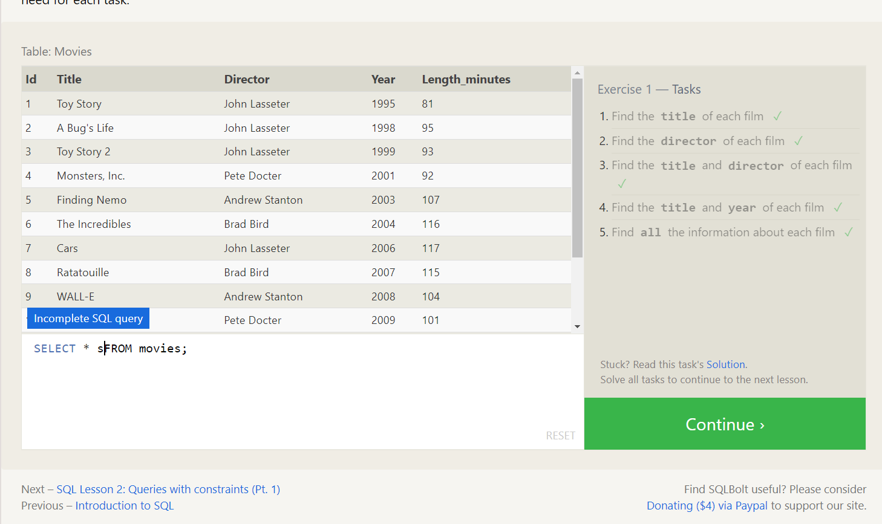

SQL Lesson 2: Queries With countries

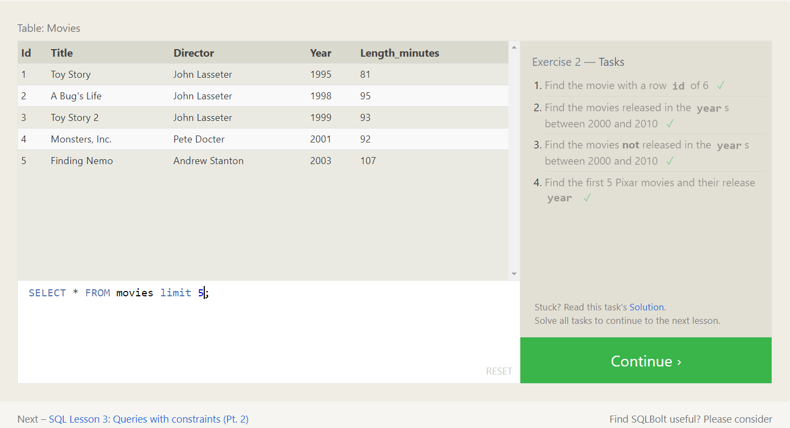

SQL Lesson 3 : Queries with constraints

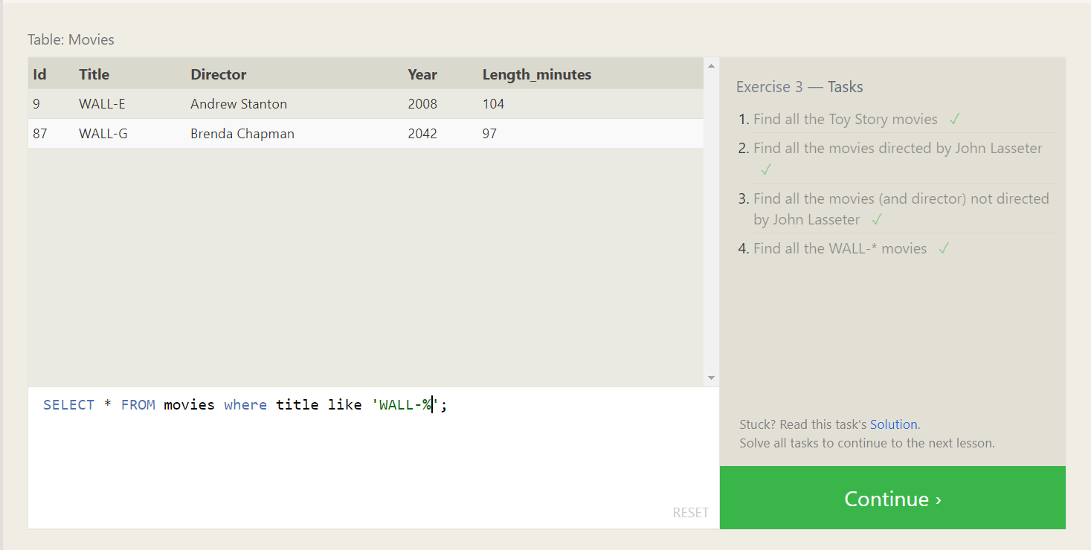

SQL Lesson 4 : Filtering and sorting Query results

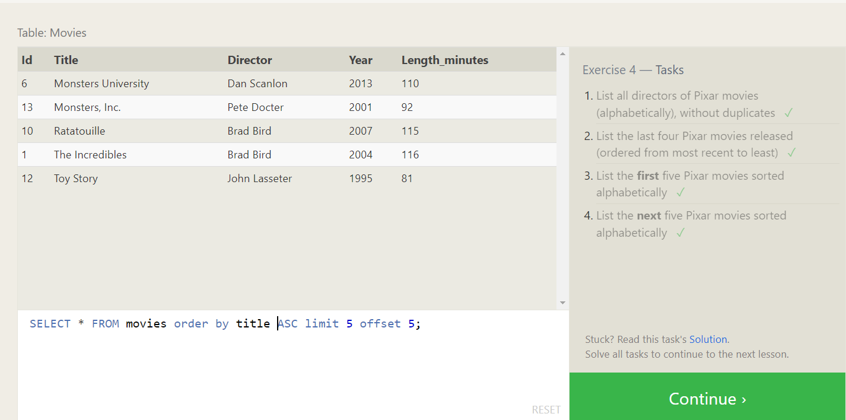

SQL Review : simple SELECT Queries

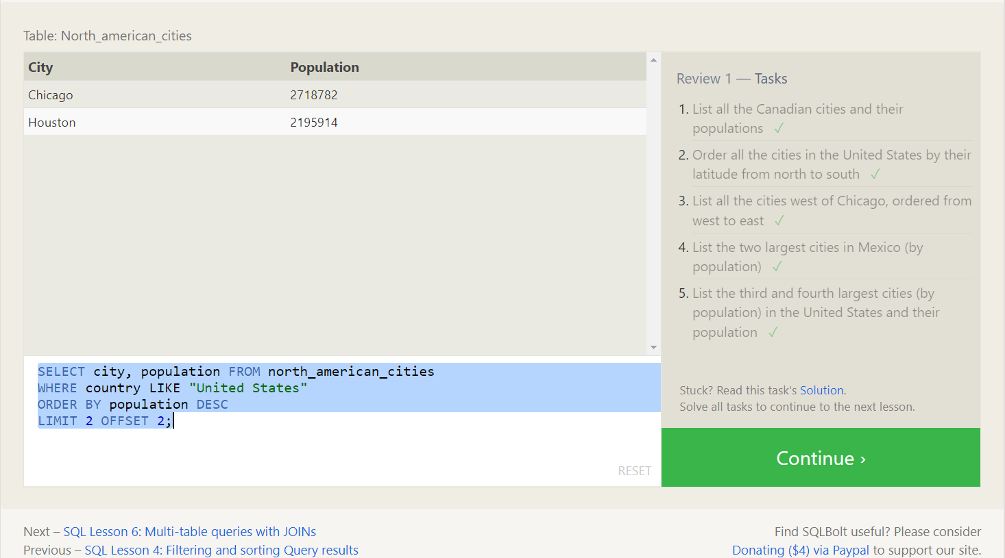

SQL Lesson 6: Multi-table queries With JOINs

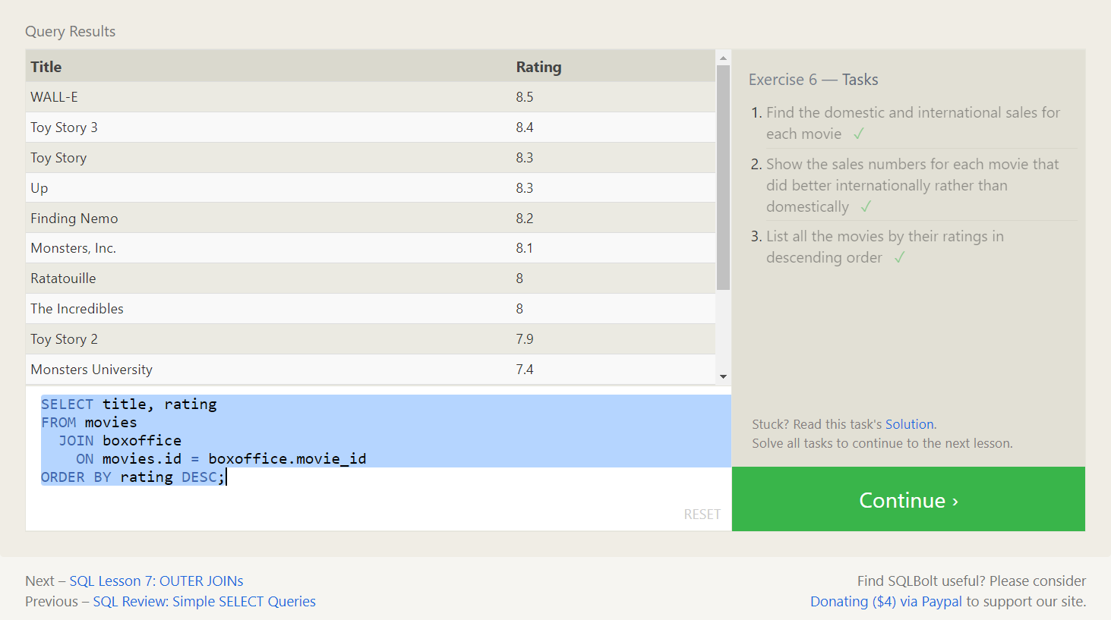

SQL Lesson 8 : OUTER JOINs

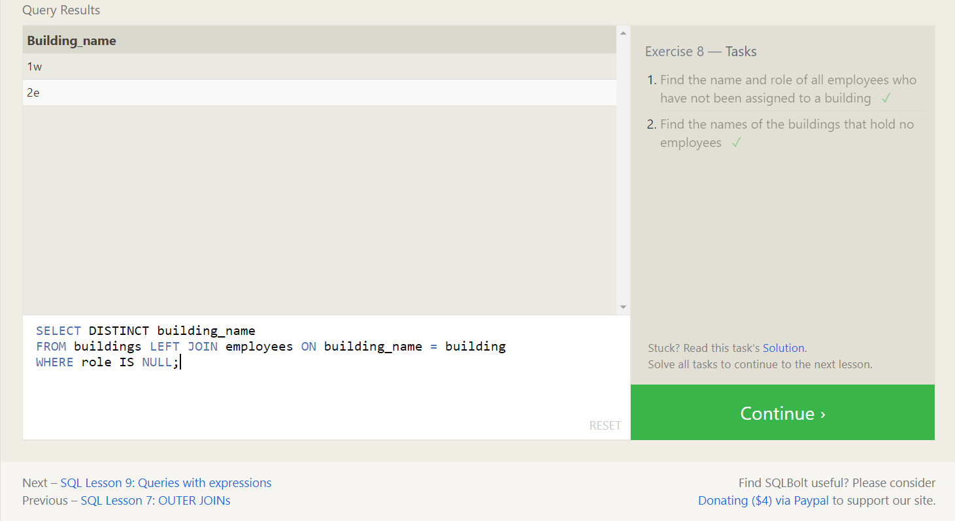

SQL Lesson 8 : A short note on NULLs



SQL Lesson 9 : Queries with expressions

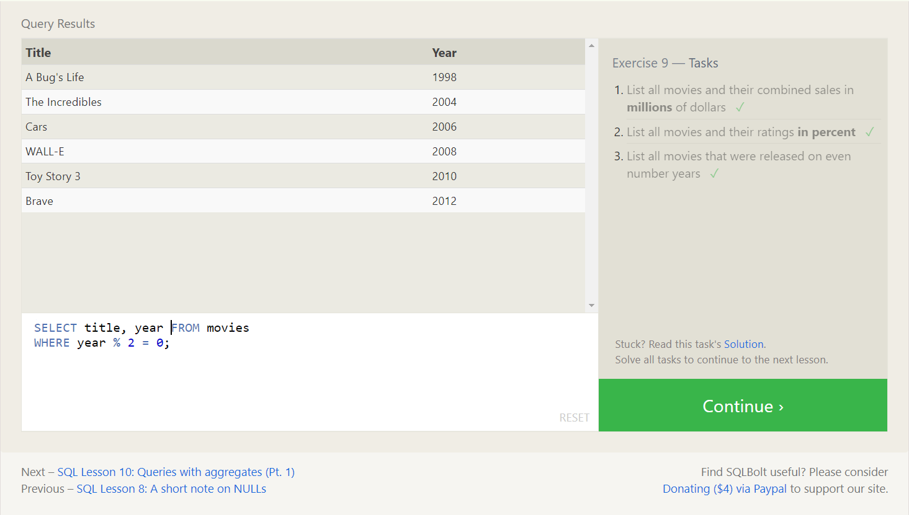

QSL Lesson 10: Queries with aggregates

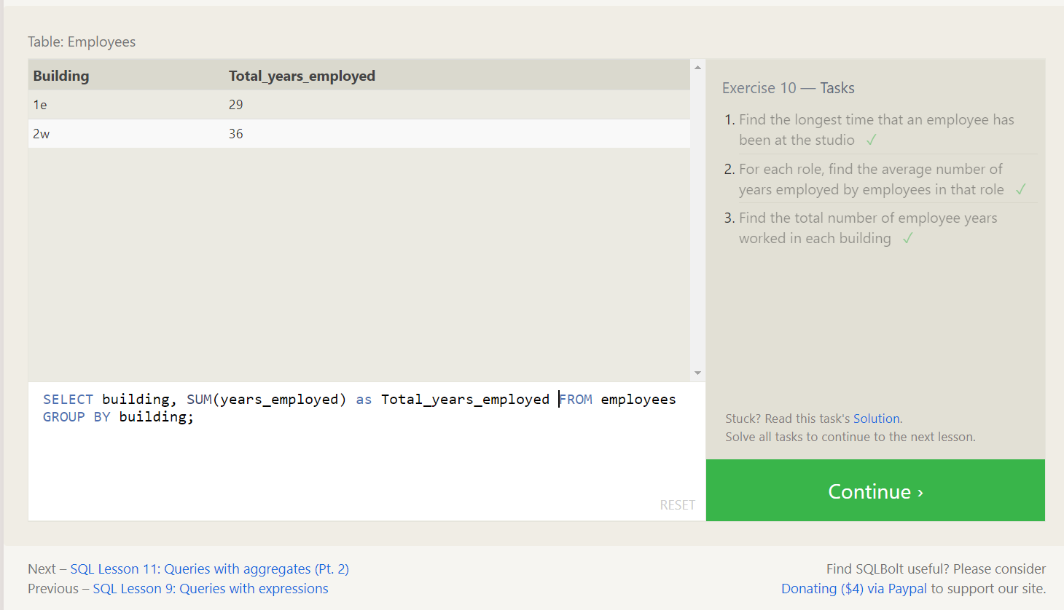

SQL Lesson 11:Queries with aggregates

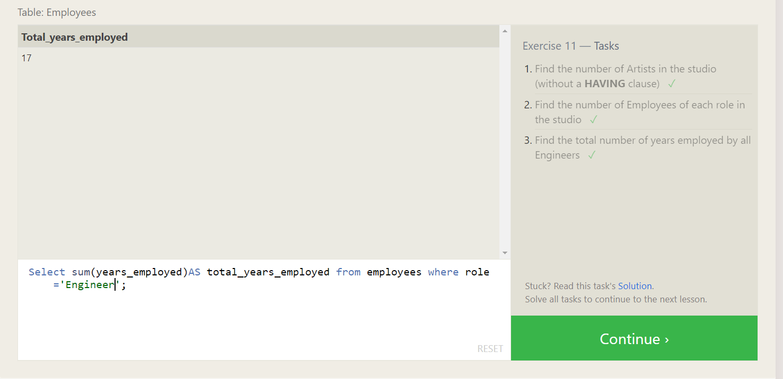

SQL Lesson 12: Order of execution of a Query

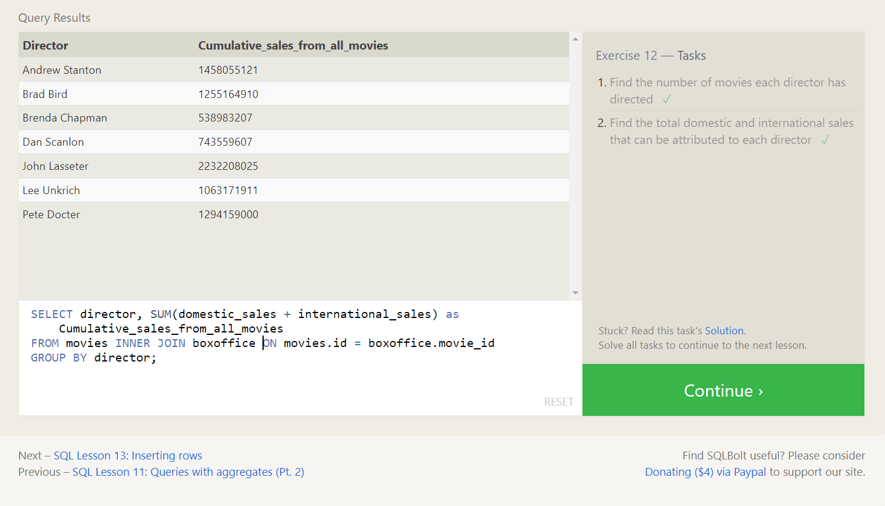

SQL Lesson 13:Inserting rows

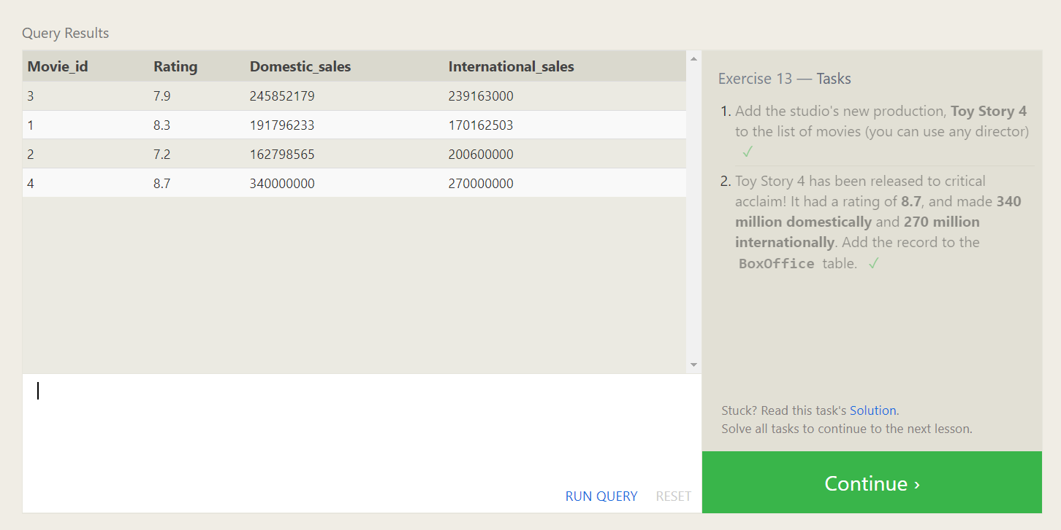

SQL Lesson 14: Updating rows

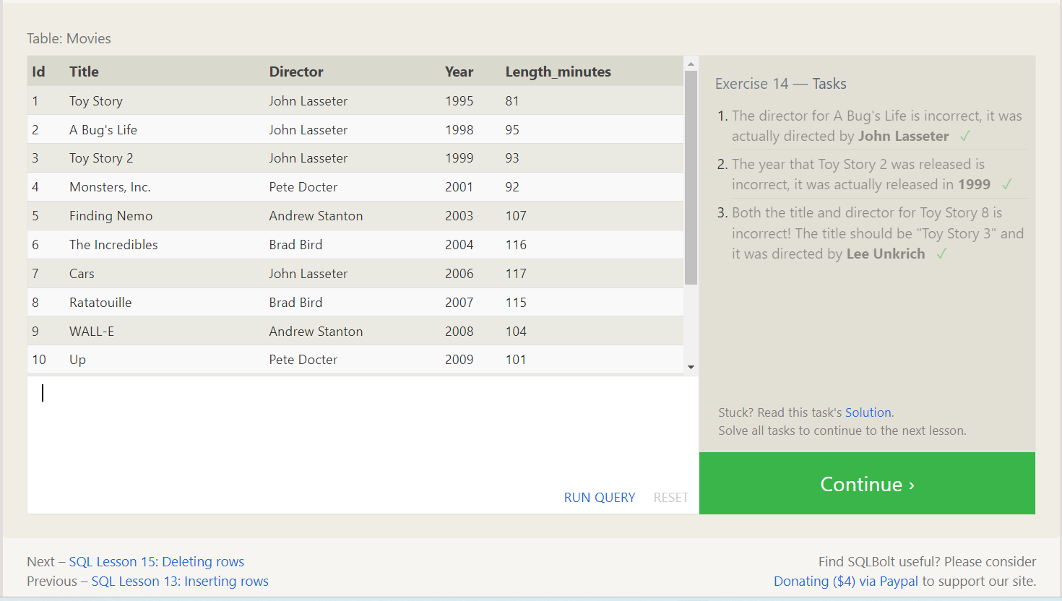

SQL Lesson 15: Deleting rows

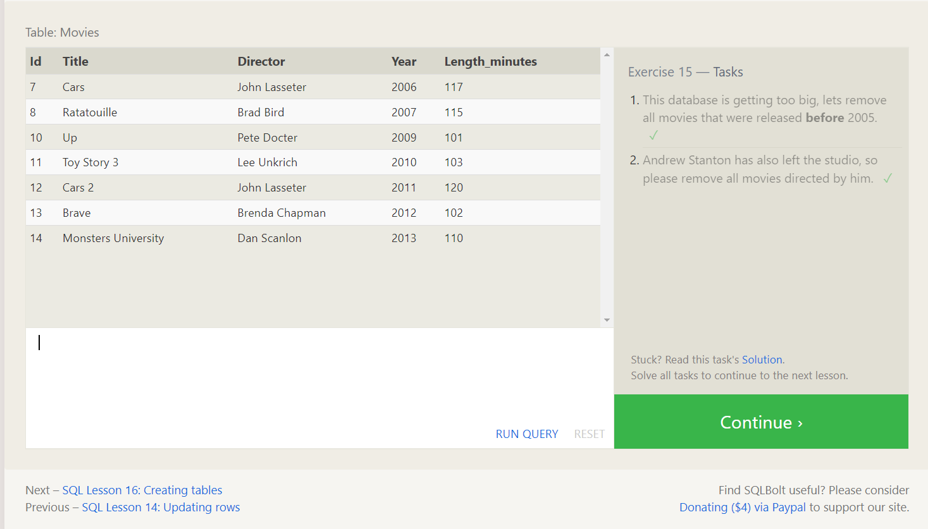

SQL Lesson 16: Creating tables

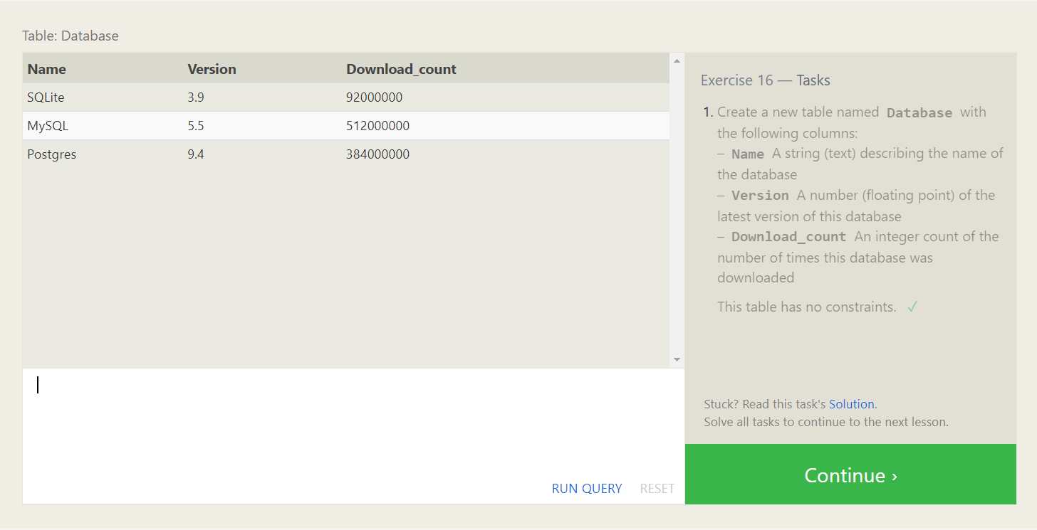

SQL Lesson 17 : Altering tables

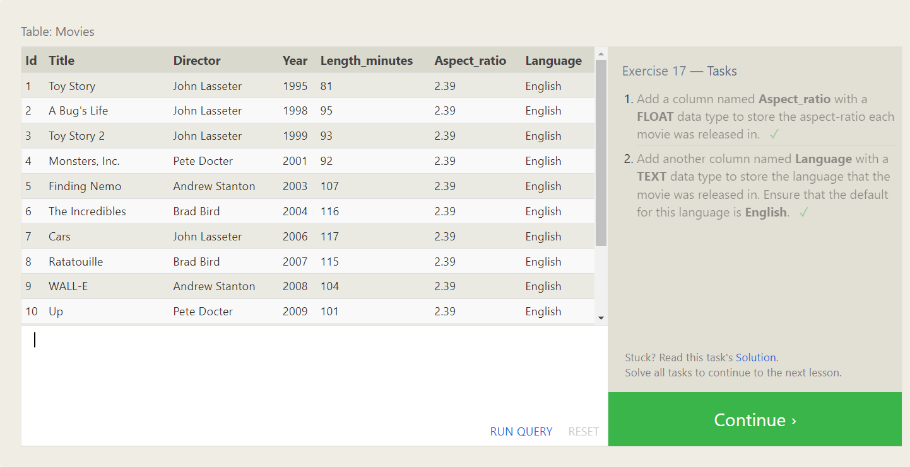

SQL Lesson 18: Dropping tables

